ST. ALBERT SINGERS GUILD

2025-2026 Sponsorship Packages
PO Box 238, St. Albert, AB, T8N 1N3
Email: SASG.President@gmail.com
Phone: 780-217-3981

Sharing our Songs - 40-years Strong!
What do you get when you mix 40 years of passion with a diverse repertoire of contemporary and classical music - then add a sprinkle of choreography and a dash of storytelling?
You get the St. Albert Singers Guild: a vibrant, community-based choral family known for delivering performances that captivate audiences of all ages. For nearly four decades, the Guild has brought joy to audiences across St. Albert and surrounding areas.
Grounded in the values of inclusivity, joy, quality, and community, the Guild warmly welcomes singers of all skill levels. Through personalized support, our members develop their vocal skills, grow as performers, and share in the joy of making music together.

Mission, Vision & Values
Mission:
The St. Albert Singers Guild is dedicated to celebrating and promoting excellence in choral performance. We aim to educate and inspire our singers, supporters, and audiences; and to enrich lives through the power of music.
Our Core Values:
- Joy
We believe in the uplifting, shared experience of choral music. We value the enjoyment and enrichment it brings to our singers, families, and audiences alike.
- Quality
We pursue excellence through thoughtful repertoire choices, high performance standards, and a commitment to inspiring both our members and those who listen.
- Community
We are strengthened by the support and contributions of singers, families, volunteers, and audiences working together. Community involvement is at the heart of everything we do.

Our History

Our origin story begins when Dr. Lillian Upright, in 1986, formed a choir as an offshoot of her church choir. Over the next few years, the choir grew under the successive directorship of Tim Hankewich, Jan Dammann, Eric Mierau, and Criselda Mierau.

What began as a mixed choir of 24 voices quickly grew to almost 50 singers, with many on a waiting list. As the popularity of the inclusive Guild community grew, the programming expanded to include six choirs: The St. Albert Singers (“SAS”), the St. Albert Women’s Vocal Ensemble (“SAWVE”), and for a time, four children’s choirs. Over the years, the Guild performed on numerous tours in western Canada and internationally in Germany and Ireland.

Like most live performing arts organizations, the Guild was financially and operationally hit hard by the 2020 COVID-19 pandemic. Rehearsals, concerts and fundraising activities had to be suddenly cancelled. Membership fee refunds, reductions in donations and a temporary loss of funding from grants resulted in a significant loss of revenue. By the end of the 2022-2023 season - our first full season after the pandemic - through the assistance of many volunteers and a laser-focus on fundraising, the Guild recovered from the $30,000 deficit caused by the long shut down.

With the launch of our 2023-2024 season, we warmly welcomed our new Artistic Director, Caroline Crispin. An enthusiastic music teacher and accomplished musician, Caroline brings a community focus and a desire to share music with all ages and levels of experience.


Who We Help

The St. Albert Singers Guild is more than just a choir. It’s a place where music, friendship, and community come together. The love of singing and bringing joy to others through performance is something we all share, no matter our background or musical experience.

St. Albert, Edmonton and Morinville Communities:

The Guild brings people together through free live performances in churches, senior living facilities, and community centers. For seniors, these concerts are more than entertainment — they spark memories, lift spirits, ease stress, and support overall well-being.

Within our Choir Family:
Inside the Guild, our members find a welcoming and supportive family where music and friendship go hand-in-hand. Together we:
- Learn and grow through singing.
- Build lasting friendships and celebrate milestones.
- Experience the physical and emotional benefits of making music together.
It is also our long-standing policy to ensure that financial barriers never prevent participation. When needed, the Guild discreetly covers membership fees for those with limited resources, because we believe that everyone deserves access to the joy, community, and health benefits of singing together.

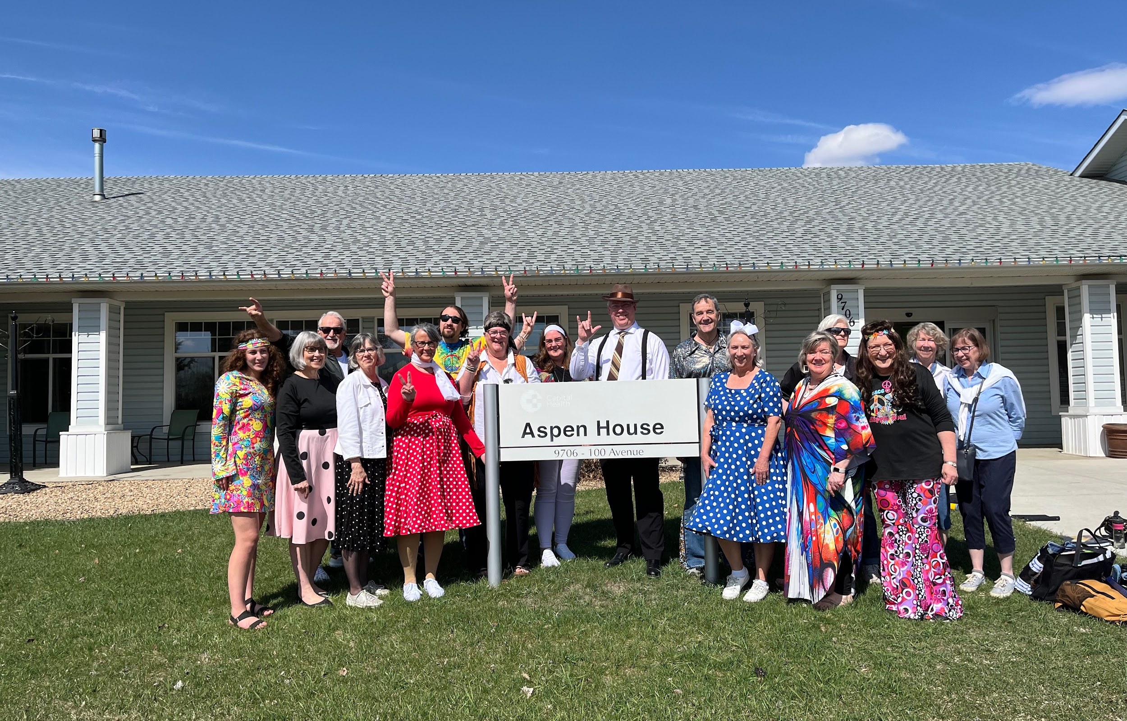

Our Impact
“Choral music is not one of life’s frills. It’s something that goes to the very heart of our humanity, our sense of community, and our souls…It’s like a great oak that rises up from the center of the human race and spreads its branches everywhere. That’s what music does for us. And choral music must stand as one of the supreme examples of it.”
John Rutter: The Importance of Choir 3/31/2015 http://www.jwpepper.com/johnrutter

“The St Albert Singers Guild has come to perform at our 55+ retirement residence twice this year. The group is phenomenal. Their song choices, energy and clear love of music make for an amazing show. We even get some residents up dancing. I cannot express how much we appreciate them volunteering their time to entertain us!”
Maria Tarnowski, Careadon Village Activity Coordinator, May 10, 2025

“I have been a member of the St. Albert Singers Guild for 25 years. I have always loved to sing, but cannot read music, so I thought I would never be able to join a choir. I was wrong. The SASG allowed me to join with nothing more than a desire to sing. The group was so welcoming and supportive I cannot tell you how great this made me feel. The Guild has put on workshops over the years that have broadened my musicality. Music lifts my soul and brings me peace during turbulent times. It is a wonderful thing to be able to share our music with people. I will continue to sing as long as I can.”
Louise M., St. Albert Singers Guild, Treasurer & 25-year member

“I’ve enjoyed singing in choirs since 2002 and with St. Albert Singers since 2011. Singing brings great joy to my heart. It grounds me and makes me feel part of something bigger than me alone. I wish more people, and more men specifically, could open themselves to this as I have.”
Rod W., St. Albert Singers Guild, Director & 14-year member.

What Comes Next—And How YOU Can Help!

Our Upcoming Goals
- Maintain affordable concert ticket prices and membership fees – by fundraising over $33,000 per season to partially offset ever-increasing venue, operating and production costs.
- Offset music procurement and licensing costs – by raising over $3,000 per season to cover the cost of obtaining licenses to own or rent choral compositions and practice tracks.
- Replace and procure equipment and instruments – by raising over $10,000 to replace or repair aging audio equipment and instruments needed for our rehearsals.

Why Be a Sponsor?

Community Involvement:
Your support directly contributes to the cultural vibrancy of St. Albert, Edmonton and the surrounding areas, allowing us to offer free choral performances in senior living facilities and community centers.

Audience Engagement:
Your engagement reaches a dedicated and passionate local audience of more than 1,000 music lovers, families and community members each year.

Brand Visibility:
Your brand demonstrates a commitment to the arts and to supporting a respected, long-standing choir dedicated to compassion, artistry, and community service.

Sponsorship Levels (Includes cash and in-kind contributions)

Valued Friend - $500
- Acknowledgement on website sponsorship page and on concert programs and posters.

Bronze - $1,000
- Recognition at concerts (sponsor’s logo displayed on concert programs and posters).
- VIP Access: 2 complimentary tickets to each concert with reserved seating.
- Social Media Exposure: Mention in social media posts as a valued sponsor.
- Quarter-Page Ad in concert programs for all performances during the sponsorship year.
- Acknowledgement in event-related thank-you materials and program booklets.

Silver - $2,000
- Prominent Recognition at concerts (sponsor’s logo on posters, programs, and select digital materials).
- VIP Access: 4 complimentary tickets to each concert with VIP reserved seating.
- Social Media Exposure: Featured thank-you posts on the choir’s social media platforms and website.
- Half-Page Ad in concert programs for all performances in the sponsorship year.
- Sponsor Acknowledgement in event press releases and media coverage.
- Inclusion in Event Thank-You Materials: Thank-you banners at events, recognition during concerts.

Gold - $3,000
- Headline Recognition at all concert performances (sponsor's logo prominently displayed on all event materials, including posters, programs, and digital promotions).
- Custom Branding Opportunities: Featured in the concert venue (including banners, flyers, and sponsor’s table).
- VIP Access: 6 complimentary tickets to each concert, including VIP reserved seating.
- Social Media Exposure: Featured posts on the choir’s facebook account, including dedicated thank-you posts and your logo and website link prominently displayed on our website.
- Full-Page Ad in concert programs for all performances in the sponsorship year.
- Prominent Mention in press releases and media coverage related to performances.

Please join us in changing lives through music, today.
Apply to be a sponsor here, or email SASG.President@gmail.com.

